**ASSESSMENT AND INTERNAL VERIFICATION FRONT SHEET (Individual Criteria)**

**(Note : This version is to be used for an assignment brief issued to students via Classter)**

|  |  |  |  |  |  |  |  |  |
| --- | --- | --- | --- | --- | --- | --- | --- | --- |
| Course  Title | | IT-CCD-6.1A_23 / IT-DGD-6.1A_23 B.Sc. Creative Computing / Digital Games Development | | | **Lecturer Name & Surname** | DAREN SCERRI / DAVID DEGUARA | | |
| Unit Number & Title | | | ITMMD-506-2001 | Object Oriented Programming - Multimedia | | | | | |
| Assignment Number, Title / Type | | | A03 - OOP Multimedia Game Project / Home Assignment | | | | | |
| Date Set | | | 18/12/2023 | Deadline Date | 22/01/2024 – 9.00am | | | |
| Student Name | Matthias Saliba | | | ID Number | 90804L | | Class / Group | DGD6.1A |

|  |  |
| --- | --- |
| Assessment Criteria | Maximum Mark |
| *SE2.2 - Design an Object-Oriented game or multimedia application* | 10 |
| *SE4.4 - Create robust code through the implementation of event handling techniques.* | 10 |
| *KU4.1 - Show how persistence between different scenes and/or levels can be maintained according to set requirements.* | 5 |
| *AA4.3 - Make use of persistent and secure data storage.* | 7 |
| *AA3.3 - Produce a well-structured and scalable game or multimedia application.* | 7 |
| *SE3.4 - Evaluate and defend the final outcome with a justification of techniques used.* | 10 |
| Total Mark | **49** |

|  |
| --- |
| **Notes to Students:** |
| * This assignment brief has been approved and released by the Internal Verifier through Classter. * Assessment marks and feedback by the lecturer will be available online via Classter (<Http://mcast.classter.com>) following release by the Internal Verifier * Students submitting their assignment on Moodle/Unicheck will be requested to confirm online the following statements:   **Student’s declaration prior to handing-in of assignment**   * I certify that the work submitted for this assignment is my own and that I have read and understood the respective Plagiarism Policy   **Student’s declaration on assessment special arrangements**   * I certify that adequate support was given to me during the assignment through the Institute and/or the Inclusive Education Unit. * I declare that I refused the special support offered by the Institute. |

**Section 1 – Game Design**

1a) Space Wars. Space Wars is a 2D shooting game which takes place in outer space. The player is inside a spaceship and is instructed to shoot the incoming enemies in order to survive. The aim is to eliminate as many enemies before running out of health!

**1bi) Genre :** 2D Space Shooter

**1bii) Inspirational References :** When I was young I used to play a similar game on miniclip.com.

**1biii) Basic Narrative :** The player is on a mission to find life outside of Earth, while doing that he is encountered by some aliens trying to destroy him.

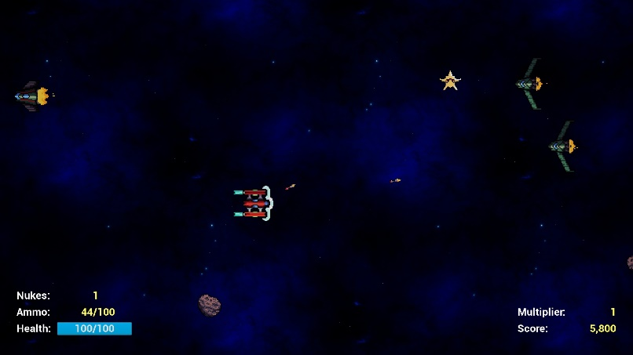**1biv)**

**1ci)** Depending on the skill and ability of the player as if he is experienced with these types of games then he/she will find it quite easy. I would say that the average player would take 4-5 minutes on the game.

**1cii)** There are 2 levels in total.

**1ciii)** The average play time would be around 10-15 minutes.

**1civ)** The objective of the game is to kill as many enemies as you can before death.

**1cv)** There is only 1 character and it is non-customizable.

**1cvi)**

**1di)** The physics is basically the enemies are falling down by gravity and the player is not affected by gravity. The laser have a force applied.

**1dii)** The movement of the player is controlled by a Rigidbody2D and it is capturing the movement of the axis and multiplying them by speed and time.Deltatime.

**1diii)** You move the player with WASD or arrow keys and shoot normal lasers by holding left click and shoot special lasers by holding right click.

**1div)** There is no communication with objects.

**1dv)** Combat is captured by a collider 2D and when the laser is in contact with the enemy then damage to the enemy is applied.

**1dvi)** The only type of economy is the score. Each enemy has a different score and when a player kills an enemy he gets more score.

**1dvii)** There are no game options.

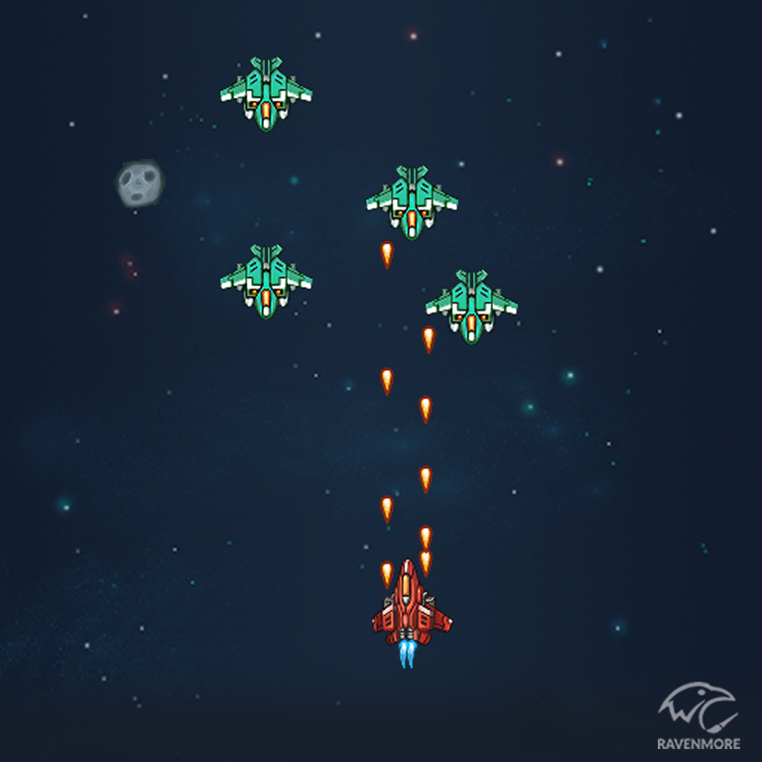**1e)** I have tried to match these layouts of art. I found free sprites to use from online websites such as ‘www.kenney.nl’ and I have tried to implement them within the game.

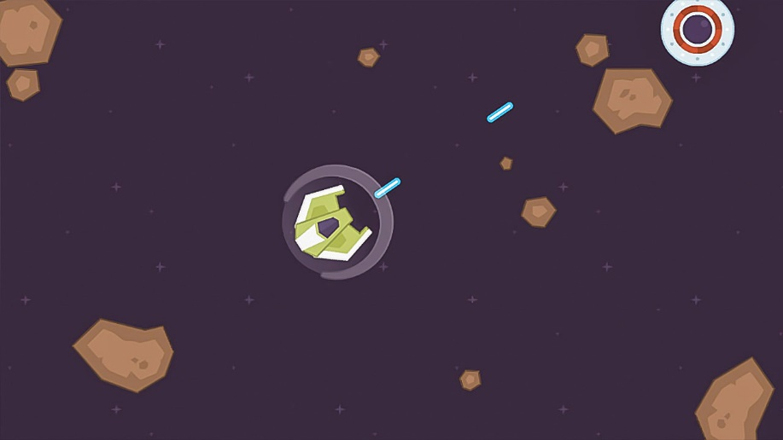

**Section 4 - The Final Game**

**NEXT PAGE**

**4.1)**

**4.3a)** In my game I used many different OOP design patterns. For example inheritance for the laser was used for the normal laser and the special laser. An abstract class to store the game data was also implemented. In this GameData I used encapsulation with getters and setters. I also used an interface for applying damage to the enemy from the GameManager class.

**4.3b)** My suggestions for improvement would be to add a background melody using DontDestroyOnLoad() and some sound effects. Different types of spaceships for the player can be implemented and the enemies can fire ammo at the player too.